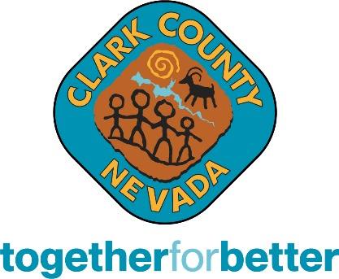 |  | News Release
 |  | County Commission  Tick Segerblom, Chairman  William McCurdy II, Vice Chairman  Michael Naft  Marilyn Kirkpatrick |  |  | Ross Miller  Justin Jones  James B. Gibson | County Manager  Kevin Schiller
Office of Communications & Strategy • (702) 455-3546 • FAX (702) 455-3558 • www.ClarkCountyNV.gov
Contact | Judge Harmony Letizia |  | Phone | 702-671-3361
 |  |  | Email | LVJCdepartment3@clarkcountynv.gov
For Immediate Release |  |  | Wednesday, Oct. 16, 2024
Las Vegas Justice Court Veterans Treatment Court Graduation

A Veterans Treatment Court Graduation and Promotion Celebration will take place on Wednesday, Nov. 13 at
11 a.m. in Courtroom 8C, 8th floor, of the Regional Justice Center at 200 Lewis Ave. in downtown Las Vegas. Marine Corps Veteran and Purple Heart recipient, Shamus Flynn, will be the keynote speaker.

Many veterans return from their military service with difficulty transitioning to civilian life. This is especially true of veterans who spent time deployed in combat zones during times of conflict or war. These men and women are among our nation’s greatest assets.

More than half of the 2.6 million veterans deployed to Iraq and Afghanistan return with mental health conditions related to their service. One in six struggles from addiction; one in five have PTSD. Left untreated, these issues make it difficult to adjust to everyday life after they return and can lead to unemployment, homelessness, and arrest. There are 700,000 veterans in the criminal justice system today, many of them arrested for charges directly related to trauma, addiction, or mental illness.

The Veterans Treatment Court provides an alternative to incarceration that offers treatment, accountability and structure while connecting the veteran to services and benefits they have earned.

To progress and graduate from Veterans Treatment Court, each individual must have attended treatment sessions, counseling and appointments; developed goals for their future; obtained housing; be financially stable; and be drug and alcohol free for a minimum of 90 days prior to graduation. These veterans are working hard to regain control of their lives. We welcome members of the community to come celebrate their accomplishments.

Judge Harmony Letizia was appointed to preside over Veterans Treatment Court in March 2018 by then-Chief Judge Joe Bonaventure. Prior to her judicial election, Judge Letizia represented many veterans participating in the Veterans Treatment Court Program in her capacity as a Public Defender.

###

Clark County is a dynamic and innovative organization dedicated to providing top-quality service with integrity, respect and accountability. With jurisdiction over the world-famous Las Vegas Strip and covering an area the size of New Jersey, Clark is the nation’s 11th-largest county and provides extensive regional services to 2.3 million citizens and 45.6 million visitors a year (2022). Included are the nation’s 8th-busiest airport, air quality compliance, social services and the state’s largest public hospital, University Medical Center. The County also provides municipal services that are traditionally provided by cities to 1 million residents in the unincorporated area. Those include fire protection, roads and other public works, parks and recreation, and planning and development.

